

Access Security System Using Face Recognition

In Fulfillment of the Requirement for the Graduation Project

Student 1: Ruai Jaber Aljadidi (14666817)
&
Student 2: Shahad Yousuf Alqusami (21988267)

Supervisor
Dr. Muataz Salam Al-daweri

Department of Information Systems

College of Economic, Management and information system

Submission May, 2025

University of Nizwa
College of Economics, Management and Information Systems

Certificate

This is to certify that the Graduation Project report entitled “ Access Security system using face recognition ” is prepared by Ruai Jaber Aljadid & Shahad Yousuf Alqusami and submitted to Department of Information Systems College of Economics, Management and Information Systems, University of Nizwa to fulfill the partial requirements for the attainment of the Bachelor degree in Web design and information security.

Department GP Coordinator Signature of the Supervisor
Dr. Nadim K. M. Madi

Countersigned by

Head of the Department

Document Reference Number
UoN/AA-POL-007/FORM-001/V3/2023


STUDENT STATEMENT OF AUTHORSHIP

We understand that we responsible for any academic work I submitted to the University of Nizwa. We declare that this assignment/project is my original work and any references and sources I have used were properly acknowledged. I claim the sole ownership of this academic work which was not done by any other person.

If the University of Nizwa discovers that the foregoing declaration is incorrect and/or that cheating or plagiarism has occurred, the University reserves the right to impose academic sanctions against me.

The copyright of this project report belongs to the University of Nizwa. The student should adhere to the University Authorship Policy [UoN/GSRER-DOR-POL/007/V1/2021].

Course Code: _________________________________
Course Title: Graduation Project
Title of Project: Access security system using face Recognition
Name of Student(s): Ruai jaber Aljadidi & Shahad yousef Alqusami
Student ID(s): 14666817& 21988267
Student Signature(s): _________________________________
Date: _________________________________



DECLARATION

We hereby declare that the Graduation Project report preparation work has been done by Ruai Aljadidi and Shahad Alqusami , and no portion of the work contained in this report has been submitted in support of any application for any other degree or qualification of this or any other university or institute of learning inside Oman or elsewhere.

[Ruai jaber Al-jadidi ] [Shahad Yousuf Al-qusami]

----------------------------------- --------------------------------



SIMILARITY CHECK REPORT

The report has been checked against the plagiarism using Turnitin. The percentage of text-similarity is 15% only. The Turnitin report is displayed below,

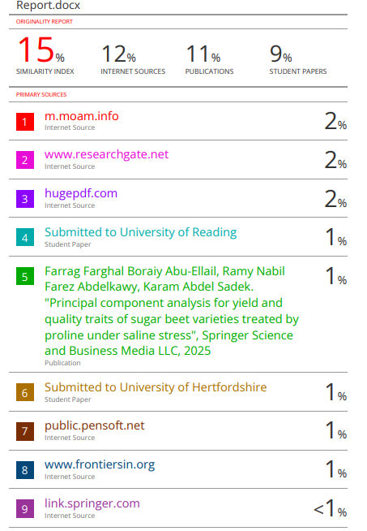









ACKNOWLEDGEMENT

We would like to thank the faculty members at the University of Nizwa., especially the members of the College of Economics and Information Systems, particularly the Department of Information Systems. This research shows the results of your efforts in providing educational content to your students and providing them with all the experiences and knowledge. We are very grateful to you. we would like to thank the National Center for Information Security for providing the opportunity to participate in the first Gulf Cyber Security Hackathon and the opportunity to attend the conference and present the idea to the participating companies. The result of that effort was crowned in this research. We are very grateful to you.



Table of Contents

Item | Page
Certificate ……………………………………………………………………………... | i
Student Statement of Authorship ……………………………………………………. | ii
Declaration ……………………………………………………………………………. | iii
Similarity Report ………………………………………………….…………………. | iv -vii
Acknowledgement …………………………………………………………………… | viii
Table of Contents …………………………………………………………………….. | ix
List of Tables …………………………………………………………………………. | x
List of Figures …………………………..……………………………………………. | xi-xii
List of Abbreviations ………………………………………………………………… | xiii
Abstract ………………………………………………………………………………. | xiv
Chapter 1: Introduction
- Introduction .…………………………………………………………………… | 1
- Problem Statement …………………………………………………………….. | 1
- Objectives ……………………………………………………………………... | 1
- Significance of the Study ……………………………………………………… | 2
- Project Scope ………………………………………………………………….. | 2
- Project Organization …………………………………………………………… | 2
1.7 Summary ………………………………………………………………………. | 2
Chapter 2: Literature Review
- Introduction ……………………………………………………………………. | 3
- Fundamental Concepts …………………………………………………….…... | 3-9
- Convolutional Neural Network (CNN)…………………………………… | 3
- Face Recognition …………………………………………….…………… | 3
- Image Classification..................................................................................... | 4
- Image Processing………………………………………………………….. | 4
- ImageNet………………………………………………………………….. | 5
- Data Augmentation……………………………………………………….. | 5
- Support Vector Machine (SVM)…………………………………………. | 5
- Support Vector Clustering (SVC)………………………………………… | 5
- Linear Discriminant Analysis (LDA)…………………………………….. | 6
- Logistic Regression (LR)………………………………………………. | 6
- Naive Bayes (NB)……………………………………………………… | 7
- K-Nearest Neighbors (KNN)…………………………………………… | 7
- Principal component analysis (PCA)…………………………………… | 8
- Multiple factor analysis (MFA)………………………………………… | 8
- Singular Value Decomposition (SVD)…………………………………. | 9
- Related Works……………………………………………………………. | 10
- Summary …………………………………………………………………….… | 10
Chapter 3: Methodology | 10-14
- Introduction …………………………………………………………………... | 11
- Methodology …………… ……………………………………………………. | 11
- Waterfall model …………………………………………………………. | 11-12
- LCA (Life Cycle Assignment)…………….…………………………….. | 13
- Requirements and Design ..…………………………………………………... | 13
3.3.1 Dataset of the system…………………………………………………….. | 13
3.3.2 Image recognition using deep neural network…………………………… | 14
- Project Gantt Chart ……………………………………………………………... | 15
- Summary ………………………………………………………………………... | 15
Chapter 4: Design and Implementation
Introduction …………………………………………………………………….............. | 16
- Implementation and Results Discussion............................................................ | 17-40
- Summary ………………………………………………………………………... | 40
- Chapter 5: Conclusion
Conclusion ……………………………………………………………………………… | 41
- Recommendations ………………………………………………………………. | 41
- Future Work ……………………………………………………………………... | 41



List of Figures

FIGURE NO. | TITLE OF FIGURE | PAGE NO.
2.1 | Naive Bayes | 7
3.1 | Waterfall model | 11
3.2 | LCA diagram show How the System Work? | 13
3.3 | Face CNN dataset. | 14
4.1 | Reading the dataset. | 17
4.2 | Data Graphing Library. | 18
4.3 | Libraries that help analyze data with machine learning. | 19
4.4 | Specify data path. | 19
4.5 | Folder source. | 18
4.6 | Ignore Code. | 20
4.7 | View data source. | 20
4.8 | Show specific images. | 21
4.9 | View all images in the file. | 22
4.10 | Display images in gray color. | 23
4.11 | Data Augmentation Implementation. | 24
4.12 | Create binary array of data. | 25
4.13 | Splitting data into training and test set. | 25
4.14 | Distribute and display data graphically. | 26
4.15 | Random distribution of data. | 27
4.16 | Random distribution of data. | 28
4.17 | Explained variance curve. | 29
4.18 | Retention data. | 30
4.19 | Reducing data dimensions. | 30
4.20 | Average face. | 31
4.21 | Principal Component Analysis. | 32
4.22 | Classification using SVM. | 33
4.23 | Confusion Matrix. | 34
4.24 | Classification Report. | 35
4.25 | Accuracy Score. | 35
4.26 | Shaded graph function. | 36
4.27 | Open the library OpenCV. | 37
4.28 | Open the camera. | 38
4.29 | Specify the files used to verify data. | 39
4.30 | Grant or deny access. | 40



List of Symbols/Notations/Terminologies/Abbreviations/Acronyms

Symbols/Notations/Terminologies/Abbreviations/Acronyms Used | Meaning
CNN | Convolutional Neural Network.
ANN | Artificial neural network.
DNN | Deep Neural Network.
SVM | Support Vector Machine.
SVC | Support Vector Clustering.
LDA | Linear Discriminant Analysis.
LR | Logistic Regression.
NB | Naive Bayes.
ANB | Augmented naive Bayes.
KNN | K-Nearest Neighbors.
LCA | Life Cycle Assignment.
PCA | Principal Component Analysis.
MFA | Multiple factor analysis.
SVD | Singular Value Decomposition.
RNN | Recurrent Neural Network.

Abstract

A facial recognition security system can be built to protect websites from unauthorized access or the use of other users' permissions. It relies on a company-specific dataset containing all the information of those authorized to access the site, along with their usage permissions. This system uses cameras that capture images of people's faces, which identifies the person trying to access the site and determines their permissions to use the system if they are authorized. By executing the code, it is clear that the system has the ability to distinguish between authorized and unauthorized users, enhancing site security. This information is contained in the company's dataset. The system uses a CNN model trained using a CNN facial dataset collected for website users. It includes all images and data of those authorized to access the site, which determines the permissions of each authorized user when entering the site.

Chapter 1

INTRODUCTION

  - Introduction
Security systems are important in protecting confidential or personal information ,With the advancement of science and technology, the facial recognition system has emerged. It is one of the excellent technologies that has many advantages that enhance security in the system. Its main task is to verify the people authorized to enter the system with complete accuracy and speed and reduce the use of the traditional method of entry, which facilitates the entry process with complete efficiency.

  - Problem statement
The known problem is that facial recognition fails to handle uncontrolled facial changes that deviate from its previous assumptions, such as changes in facial expressions and changes in lighting. These changes go beyond the assumptions on which the comprehensive models are based, which leads to their paralysis in some cases. These changes can affect the accuracy of recognizing faces. One solution is to use local features such as (gabor, lab), which are analysis tools used in image processing and also stability in the face of lighting changes, and then use machine learning to improve the accuracy and efficiency of these features [1].

The most common problem is the lack of good-quality data or uneven class balance within the datasets. These days, the most effective Deep Neural Network (DNNs) are very large, hence require huge amount of data which in many cases may be hard to provide. For instance, very popular CNN architecture VGG16 is made of 16 layers of neurons and consist 138 millions of parameters in total. Moreover, the efficiency of new architectures is usually tested on ImageNet, the dataset which contain more than one million images from 1000 non-overlapping categories. One of the ways of dealing with this problem is data augmentation and data synthesis [2].

  - Project objectives
- To implement a complex method to recognize faces accurately using CNN for building a security system.
- To implement data augmentation and data synthesis to improve the input of the face recognition model.

  - Significance of the Study
The importance of this study is evident in finding a security solution capable of analyzing user data based on artificial intelligence in order to reduce the problem of unauthorized entry into the system as well as the use of third party privileges while accessing the system.

  - Scope of the Study
This study aims to explore an access security system using facial recognition technology, with a particular focus on data analysis using artificial intelligence and decision-making based on it. The study will limit this system's use to data from the Face CNN dataset, as this dataset provides the most relevant data for the research topic.

  - Project Organization
The organization process is one of the important processes to ensure the performance and continuity of work and achieve the desired results. The establishment of such systems requires knowledge of all modern technologies that play a major role in achieving all the requirements of the system, which aims to establish a secure access system for websites using facial recognition technology, which relies on analyzing the user's facial print to identify him and grant him permission to enter the site or prevent him from entering.

1.7 Summary
This project aims to build a system with facial recognition technology using different techniques such as deep learning and data augmentation to face the challenges faced such as facial changes. The system seeks to provide a security system for safe entry.

Chapter 2

LITERATURE REVIEW

  - Introduction
Security systems are important in protecting confidential or personal information. With the advancement of science and technology, the facial recognition system has emerged. It is one of the excellent technologies that has many advantages that enhance security in the system. Its main task is to verify the people authorized to enter the system with complete accuracy and speed and reduce the use of the traditional method of entry, which facilitates the entry process with complete efficiency.

  - Fundamental Concepts

2.2.1 Convolutional Neural Network (CNN)
Artificial neural networks (ANNs) are derived from the neural networks of animal brains. Networks are made up of interconnected nodes called neurons, which are inspired by the biological neurons found in brains. The study also stated that Bezdan and Dzakula defined Artificial neural networks ) ANNs( and classified them as a type of artificial neural network that plays a role in visual tasks, which led to excellent performance in image retrieval, classification, object detection, and face recognition.[3].
The neural network was inspired by the brain through its task of processing large amounts of information, as a single neuron has a receptive field and connects to other neurons that play a major role in responding to stimuli in the visual field and is known as the receptive field. However, in the neural network, each neuron processes only the data that was received, and the artificial neural network ) ANNs( has become important in the fields of computer vision [3].

2.2.2 Face Recognition
It is a prominent biometric identity verification technology. It has been widely adopted in various fields, such as the military, and has become widely used.. This study demonstrates the shift from traditional methods to deep learning. This technology works through stages, which are face detection, then pre-processing, and then extraction. The features are then matched against the database [1].

2.2.3 Image Classification
One of the fundamental problems of computer vision and the foundation of many visual identification domains is image classification, which has emerged as a traditional study topic in recent years. As an example, object-detection, segmentation, human position estimation, video classification, object tracking, and super-resolution technologies all benefit greatly from improved classification network performance. Enhancing image categorization technology is a crucial component of advancing computer vision research. Pre-processing image data, feature extraction and representation, and classifier creation are its primary steps. Since image feature extraction is the foundation of image classification, it has traditionally been the focus of image classification research. More attention is paid to manually setting particular picture features in traditional image feature extraction methods. This approach lacks portability and generalizability. Therefore, researchers hope that a computer will be able to process images in a manner similar to biological vision. An abstract biological neural network, or ANN for short, is a mathematical operation model made up of many interconnected neurons. It roughly mimics how neural networks handle brain signals [4].

2.2.4 Image Processing
Image processing is the manipulation of an image by a computer that subjects the digital representation of an object to a series of operations in order to obtain the desired result. Instead, this work has been considered a new definition of image processing, where images are processed by a CNN, which works in a way that takes an image and begins its processing by obtaining a digital image which is in the form of an array of pixels.Image processing is also done in the medical field, and image processing is one of the important stages in medical procedures and surgical operations[5].

2.2.5 ImageNet
The ImageNet dataset consists of numerous high-resolution images that have been labeled into 22,000 categories. Amazon Mechanical Turk was used to ensure that images were collected only from the internet. Two human classifiers were assigned to classify and label the images. The ImageNet challenge has been a large-scale challenge since 2010. The ILSVRC is based on a subset of ImageNet that contains numerous images for each category. The most important sets are test sets, validation sets, and training sets. The system requires fixed dimensions, so the image resolution was reduced and the middle part was cropped to dimensions of 256 x 256 after rescaling the image. Preprocessing involves removing the average activity in the training set [6].

2.2.6 Data Augmentation
Data augmentation is a very important set of algorithms that create complex data based on available data. Complex data often contains very small changes so that the model can predict reliably. Complex data can also represent combinations between distant examples that are difficult to infer. Data augmentation is considered one of the most useful methods for improving the training of deep neural networks [7].

2.2.7 Support Vector Machine (SVM)
Support Vector Machines (SVMs) have been utilized for pattern recognition and address the problem of face recognition. They have been used in two databases. The first database (Cambridge Oral) contains 400 images with high levels of contrast, expressions, and facial details. It has also been tested with a larger database containing 1079 images. Face recognition using SVMs has been compared with the standard approach for self-faces, based on the Nearest Center Classification (NCC) criterion. It is thus indicated that SVMs are a more accurate technique for face recognition than NCC, especially when dealing with databases containing large variations in facial expressions and poses [9].

2.2.8 Support Vector Clustering (SVC)
Support Vector Machine (SVM) achieves excellent and high-dimensional hyperparameters , This technique is generally used in classification, regression, and many other tasks. Effective separation is achieved by the hyperparameter that achieves the largest distance between itself and the nearest training data point from any class, which is called the functional margin. There is an inverse relationship where the larger the margin, the lower the probability of errors in generalizing the classifier [10].

2.2.9 Linear Discriminant Analysis (LDA)
Linear discriminant analysis is a very clever analysis because it helps in reducing redundant information or information that does not make a difference. This technique is utilized for reduce the dimensionality of data by converting the original data into low-dimensional data. The essence of this technique is that it measures the variance within each class, which enhances the expressiveness of the features [11].

2.2.10 Logistic Regression (LR)
Logistic regression is based on binary outcome probabilities, a concept that is extremely important in many statistical applications. To simplify, let's consider one outcome level as a primary event, which we will call the "event" in the following text. The odds of an event express the ratio of the probability of its occurrence compared to the probability of its non-occurrence. These probabilities are commonly used in gambling, where "even odds" (odds = 1) mean that the event will occur halfway through. For example, when a single die is thrown, the odds of getting an even number are 0. The odds of getting a number less than 5 are 2, because the probability of getting a number less than 5 is twice as likely as getting a 5 or a 6. Probabilities can also be expressed symmetrically by taking the reciprocal, where the odds of getting 5 or more are 0.5 (= 1/2) [12].

2.2.11 Naive Bayes (NB)

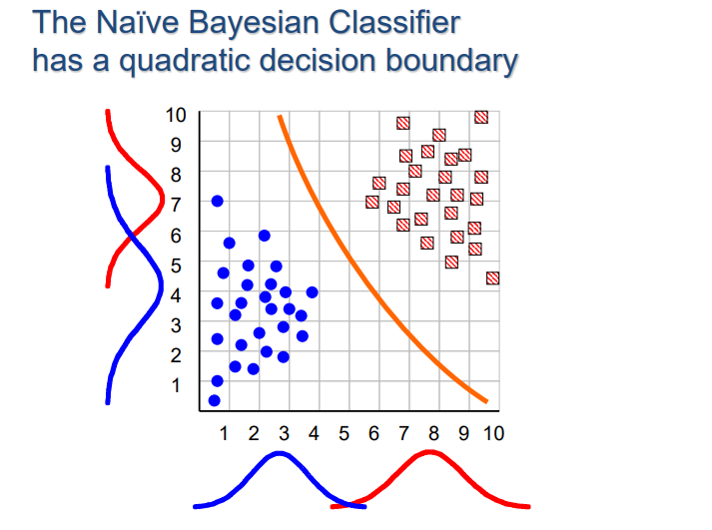
Figure(2,1) Naive Bayes[13].

One of the important issues in machine learning is classification and data or pattern extraction. The goal of the learning algorithm is to build a classifier based on a set of training examples, usually e representing the attribute values (.., x2 x1), where xi is the value of the attribute Xi. Let C represent the classification variable, and c is the value of C. In this paper, we assume there are only two classes: + (positive class) or − (negative class) [14].

A classifier is a term used to describe classes from a probability perspective. The naive Bayes model is the simplest form of Bayesian networks, assuming that all attributes are independent of the value of the class variable. This assumption is rarely true in most practical applications. One straightforward way to overcome the limitations of naive Bayes is to extend its structure to represent dependencies between attributes. In naive Bayes, a class node directly refers to all attribute nodes, and there are links between attribute nodes [14].

2.2.12 K-Nearest Neighbors (KNN)
The nearest neighbor algorithm is a technique used for classification in artificial intelligence. The basic idea of this technique is In the absence of any prior information about the distribution of data or it is nonexistent. Its idea is that it depends on measuring the new point and the nearest points to it in the data. In the publications of the US Air Force School of Flight Medicine, Fix Hodges presented a method for classifying patterns. In 1967, scientists Cover & Hart proved that the classification accuracy when k = 1 and the number of data is infinite (n → ∞) [15].

2.2.13 Principal component analysis (PCA)
is a multivariate method that examines a data table where observations are explained by a number of quantitative dependent variables that are correlated with one another. Its objective is to depict the pattern of similarity between the variables and observations as points on maps, extract the key information from the table, and express it as a collection of new orthogonal variables known as principal components. Cross-validation methods like the jackknife and bootstrap can be used to assess the quality of the PCA model. For handling qualitative variables, PCA can be generalized as correspondence analysis (CA), and for handling heterogeneous sets of variables, it can be generalized as multiple factor analysis (MFA). In mathematics , Principal component analysis( PCA) is dependent on the singular value decomposition (SVD) of rectangular matrices and the eigen-decomposition of positive semi-definite matrices [16].

2.2.14 Multiple factor analysis (MFA)
An extension of principal component analysis (PCA), multiple factor analysis (MFA, also known as multiple factorial analysis) is designed to handle multiple data tables that measure sets of variables collected on the same observations. Alternatively, (in dual-MFA), multiple data tables where the same variables are measured on different sets of observations. MFA moves forward in two stages: Each data table is first given a PCA, and all of its elements are then "normalized" by dividing them by the first singular value.derived from its PCA. A (non-normalized) PCA is then used to evaluate the grand data table, which is created by combining all of the normalized data tables. This provides a set of factor scores for the observations and loadings for the variables. A collection of partial factor scores for the observations that represent the particular "view-point" of each data table is also provided by MFA. Remarkably, the normalized factor scores derived from the PCA of each of these tables may be used to replace the original normalized data tables in order to produce the common factor scores [17].

2.2.15 Singular Value Decomposition (SVD)
Singular value decomposition (SVD) and principal component analysis (PCA) can be powerful tools for accurate characterization. These two techniques are common approaches to multivariate data analysis, and gene expression data are ideally suited for use with SVD and PCA. A single microarray experiment can produce measurements for thousands, or even tens of thousands, of genes. Current experiments typically involve fewer than ten tests, but can include hundreds (Hughes et al., 2000). Currently, gene expression data are considered to be somewhat noisy, and SVD can detect and extract small signals from these noisy data [18].

Our descriptions are applicable to both SVD analysis and Principal Component Analysis (PCA) because to the mathematical relationship between the two methods when PCA is computed using the covariance matrix. Our objectives are to: 1) describe and illustrate the use of SVD techniques and interpret their outcomes; 2) lay the groundwork for comprehending earlier SVD applications to gene expression analysis; and 3) offer interpretations and citations to relevant work that could spur further developments. Section 1 defines the SVD and describes its relationships to other techniques. To provide guidance for SVD analysis of gene expression data, an overview of prior uses is provided, Applications of SVD to gene expression analysis are covered in section 2, along with particular techniques for SVD-based gene expression data visualization and SVD's usage in identifying weak expression patterns. Examples of earlier uses of SVD for gene expression data analysis are provided. In addition to providing references to particular published SVD-based techniques for gene expression analysis, our section 3 discussion offers some broad guidelines for applying SVD analysis to gene expression data. Section 4 concludes by listing some of the resources that are available for additional reading [18].

2.3 Related Works
In the field of security studies using facial recognition technology, research and studies have demonstrated the possibility of converting image characteristics into digital data, the results of which are compared against the dataset used. This technology enables the identification of website users and granting them access rights. Algorithms that rely entirely on deep learning have evolved and emerged to improve the accuracy of facial recognition. Several algorithms have been used in this system, which have proven effective when implemented.
2.4 Summary
This chapter focuses on security techniques for facial recognition systems, discussing basic concepts such as image classification, deep learning, and others, and focusing on the role of some of the techniques that help in classification and pattern recognition.

Chapter 3

METHODOLOGY

  - Introduction
The methodology of this system is one of the most important elements that can be included in this report, which ensures the achievement of objectives accurately. The Waterfalls methodology was used to organize the process in a sequential and complete manner, as it helps in understanding the mechanism of the system and how it works, what are the steps and how to convert data from images into results that classify the user whether he is authorized or not, as this methodology enables the construction of a security system using several techniques to achieve objectives efficiently.
  - Methodology

    - Waterfall model
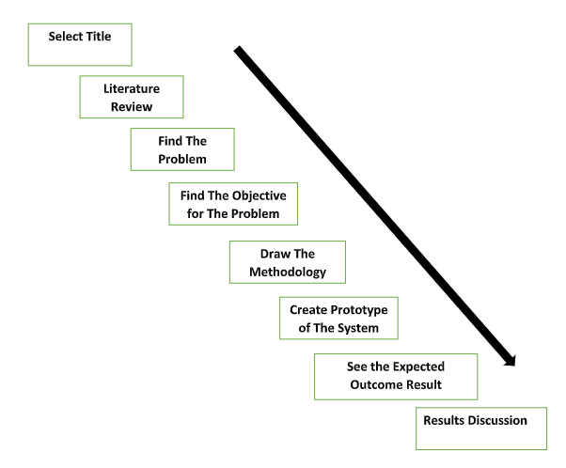
Figure(3.1) Waterfall diagram that show the step that we use to do this system.

This diagram shows the sequential steps of the graduation project, where you move from one step to another following a single, specific path:

- The first step (determining the title): This step consists of choosing a topic or title that suits the idea of ​​the project. We chose the title, which is (Access Security System Using Facial Recognition).
- Second Step (Literature Review) :After determining the title, we begin to review the research, studies and surveys that discuss the topic. There is a goal of this step, which is to collect and understand the information and techniques related to the topic to understand the experiences and goals and to know the solutions that will help in addressing the project problem.

- The third step is to define the problem (Find The Problem): This step aims to define a problem that we may face and that the project seeks to solve. The problem must be clear and understandable to facilitate finding an appropriate solution for it.
- Find the Objective for the Problem: After we define the problem, we must find the objectives that the project seeks to achieve, as the objectives are determined based on the problem that you have defined.
- Draw The Methodology: In this step, we determine the method that we will follow in solving the problem, which means that we include the steps, tools, and techniques that we will use to achieve the goal.
- Create Prototype of The System:The project prototype, a test version of the suggested system or solution, is put into use after the methodology has been developed. The prototype aids in putting the concept to the test in real life and figuring out whether it functions as planned.
- View the anticipated result and make the correction: Following the creation of the prototype, the anticipated outcomes are examined and contrasted with the initial objective. To guarantee accurate results, any mistakes or enhancements are fixed.
- Discussion of the Results: This is the last stage, where the outcomes are examined and the accomplishments assessed. Also covered are areas that could require improvement in the future and how this experience can be used to other initiatives.

    - LCA (Life Cycle Assignment)

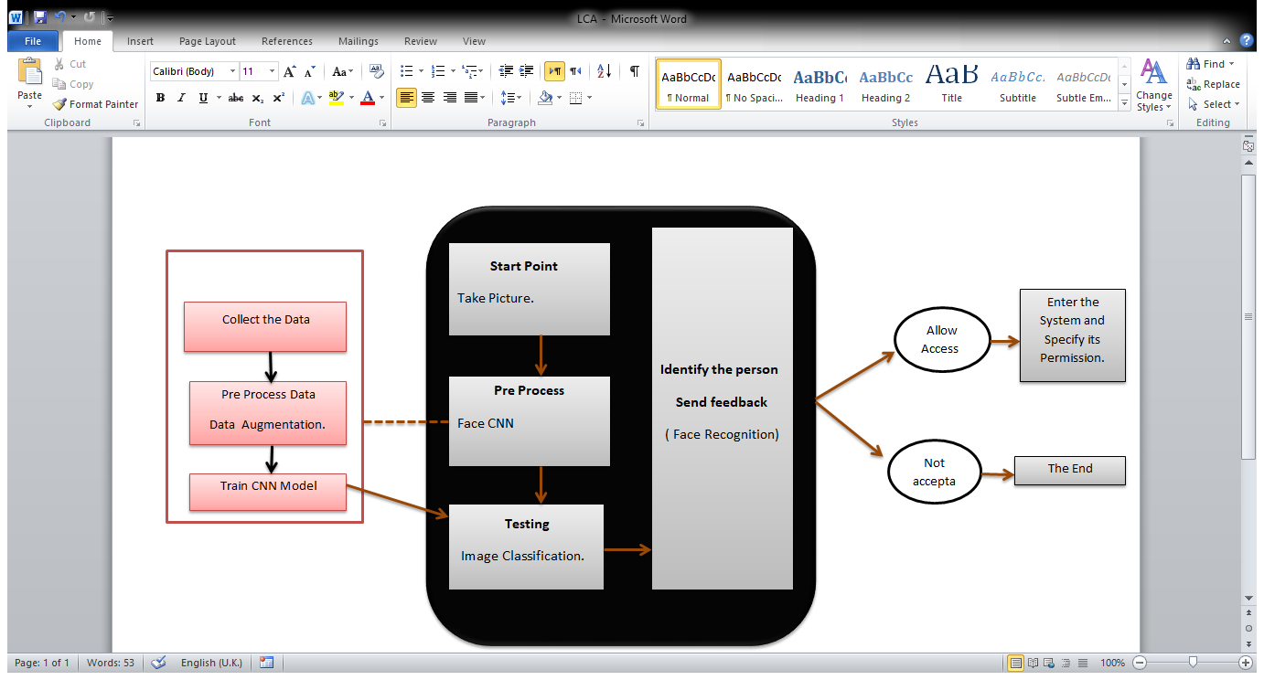
Figure(3.2) LCA diagram show How the System Work?

To learn how the system works, as we shown in the Figure (3.2):

1. Take a picture of the user who wants to enter the site.
2. Image data is re-polarized from information in the face CNN dataset.
3. Using the Trends Model to Classify Person Data.
4. A person is identified by the facial image through which the identification is made.
- If he is one of the people registered in the system, he will be allowed to enter the system and his permissions to use the system will be determined.
- If not allowed, the system allows access only to authorized user.

  - Requirements and Design

    - Dataset of the system
This system relies primarily on the data in the dataset, as it helps in identifying the degree of convergence between the existing data and the statement entered through the system, and through it the entered statement is classified.

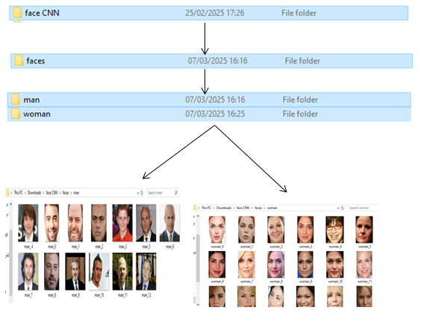
Figure(3.3) face CNN dataset.
    - Image recognition using deep neural networks

- There are tools that are needed to support the machine learning model and develop the facial recognition system, including:
- Python: used to build the facial recognition system because it supports machine learning
frameworks.
- OpenCV: This library used because it help in processing images in facial recognition
technology.
- numpy: Used to process digital data and create arrays.
- Sklearn: An open source tool used to process, classify, analyze, and find the degree of convergence between data and machine learning models.
- Several machine learning techniques help develop facial recognition systems:
- Deep Learning: The system is trained to precisely identify features or details in images using convolutional neural networks (CNNs).
- Supervised Learning: This technique uses a set of input data to train the model, which then learns patterns.
- Unsupervised Learning: This technique is used to train and discover patterns in unlabeled data
- Training Strategies:
- Model Optimization Techniques: This technique involves improving model performance during training.
- Data Augmentation: Artificial expansion is required to train a large number of images by making some changes to the images, such as rotating or mirroring them.
- Cross-Validation: This technique is implemented in the code by dividing the data into training sets and test sets.
- Performance in Different Environments:
- Recognition in Variable Lighting Conditions: The system must be capable of recognizing faces when lighting intensity varies without compromising recognition accuracy.
- Speed ​​and Efficiency: Performance in this system requires it to be able to recognize faces quickly and accurately.
- Ethical and Privacy Notes
- Privacy: The system must maintain privacy because it handles a collection of user photos, and the data is collected legally.

  - Gantt Chart
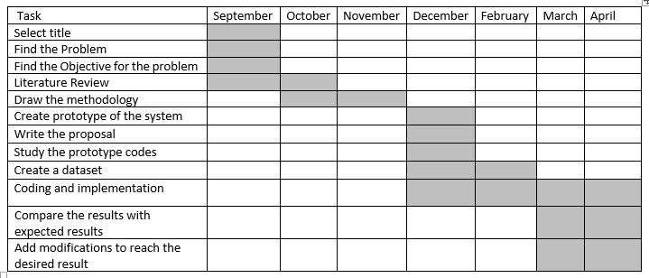

  - Summary
This chapter shows the methodologies that will be relied upon to build the system, which are represented as specific tools to reach the desired results from the system.

Chapter 4

IMPLEMENTATION AND RESULTS

  - Introduction
This chapter contains a detailed explanation of how the system works through each part of the code and the tasks it performs, and a review of the results for each part of the code.

  - Implementation and Results

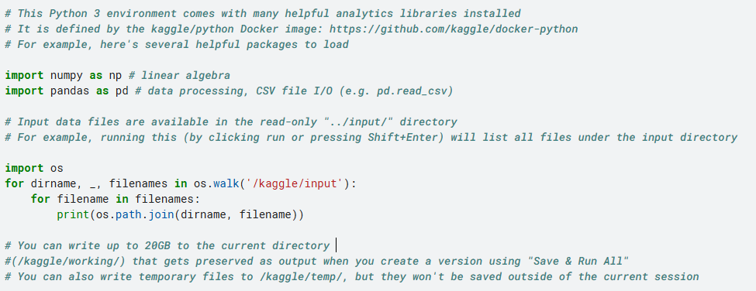
The Output:
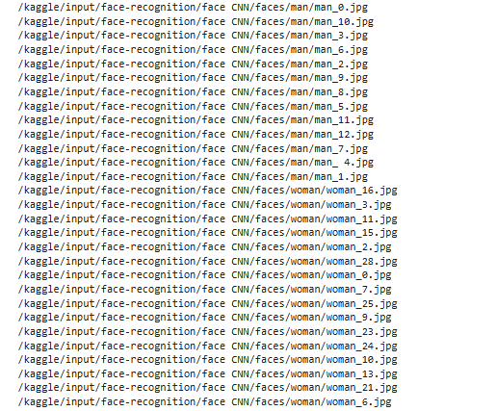
Figure 4.1 Reading the dataset.

In Figure 4.1, In this code, libraries have been downloaded to help the code work well.
import numpy as np: This library is used to find mathematical and algebraic operations.
import pandas as pd: This library is used for data processing and analysis and has the ability to handle data efficiently.
There is also an OS library whose job is to deal with files, as OS. walk was written to go through the files available in the folder, and the for loop goes through all the files in('/kaggle/input') to analyze them.

The Output:
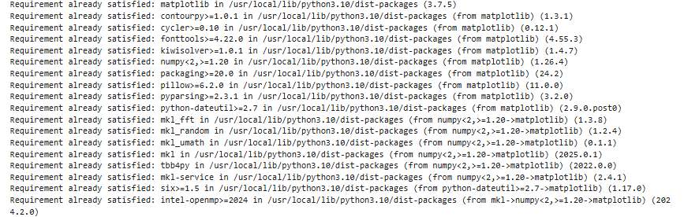
Figure 4.2 Data Graphing Library.

As shown in the Figure 4.2 , this code is a library that was downloaded to create charts, which is one of the most used tools in the field of data analysis and displaying analysis results. When executing this code, we will see the result in the output, which indicates that all libraries have been installed without the need to reinstall.
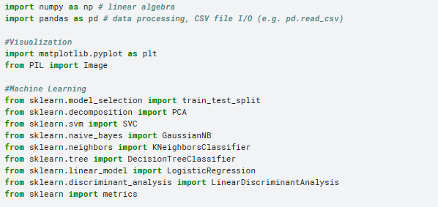
Figure 4.3 Libraries that help analyze data with machine learning.

As mentioned in the Figure 4.3 , the necessary libraries to run the code have been installed, which include sklearn, which helps in analyzing data using machine learning such as SVM, Decision Tree, KNN, Naïve Bayes, PCA, and LDA.

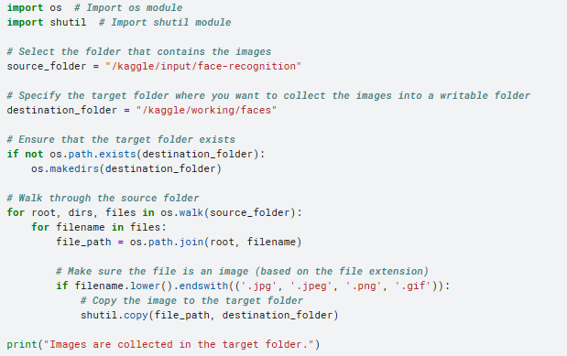
The Output:
Figure 4.4 Specify data path.

As mentioned in the Figure4.4 The code determines the folder path and checks the extension of each file (.jpg, .jpeg, .png, .gif). After collecting the images, it immediately prints the message.

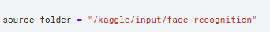
Figure 4.5 folder source.

As mentioned in the Figure4.5 code shows the source of the folder from which the images are used. So the output will be face-recognition that show the name of file.

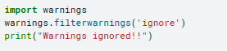
Figure 4.6 Ignore Code.

In the Figure4.6 show, all warnings that may appear during the execution of the code are ignored.

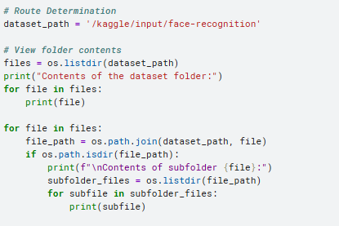
The Output:
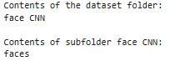
Figure 4.7 View data source.

In the Figure4.7 show, displays the folders and files in the specified path and displays the content of each subfolder.

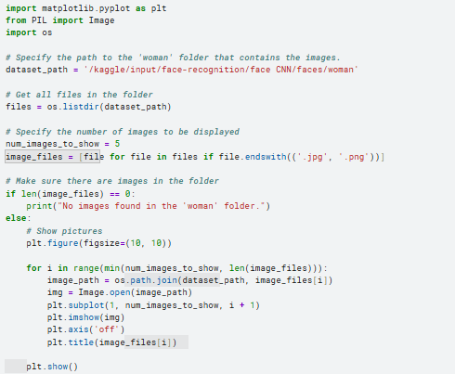
The Output:
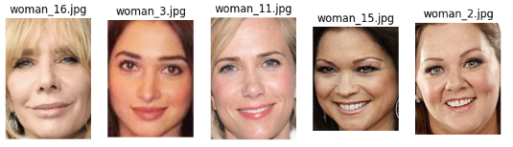
Figure 4.8 Show specific images.

As shown in the Figure 4.8 the code reads all the images (.jpg and .png), then displays the first 5 images using matplotlib with the axes hidden and a title added to each image.

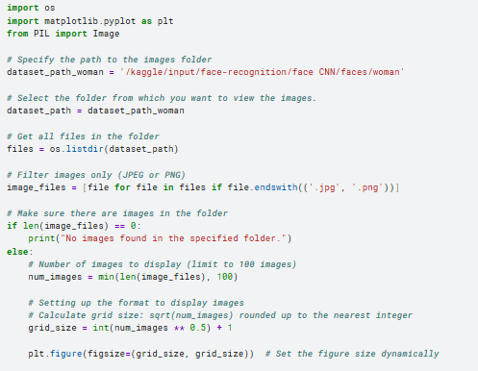
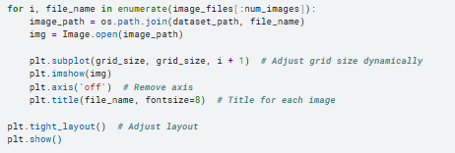
The Output:
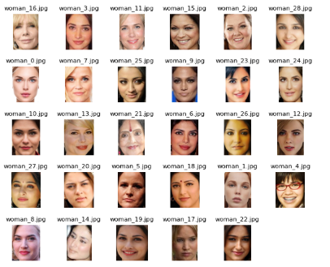
Figure 4.9 View all images in the file.

As shown in the Figure 4.9 This code displays all images in a specific file in the dataset.

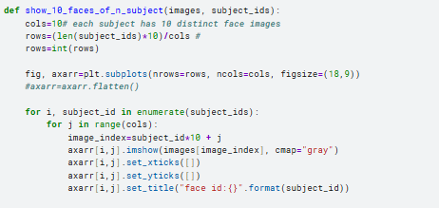
Figure 4.10 Display images in gray color.

As shown in the Figure 4.10, the Matplotlib library was used to display 10 images for each person from the subject_ids list where the images are displayed in gray and a label (face id) is added to each image.

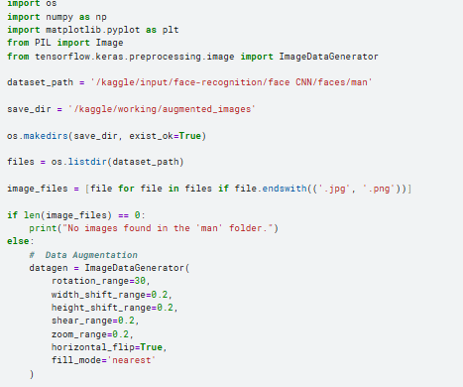
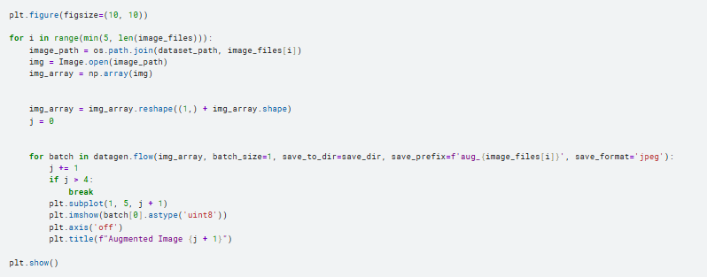
The Output:
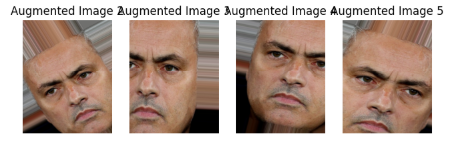
Figure 4.11 Data Augmentation Implementation.

As shown in the Figure 4.11, Some effects are performed such as rotation, changing the height and width of specific images.

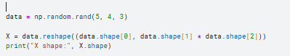
Figure4.12 Create binary array of data.

As shown in the Figure 4.12, This code is for creating three-dimensional arrays that contain (number of arrays, number of rows, number of columns).(5, 4, 3) Then, it converts the triangular matrix to a binary matrix using (number of matrices, number of rows × number of columns). So the output that will display X shape:(5,12).

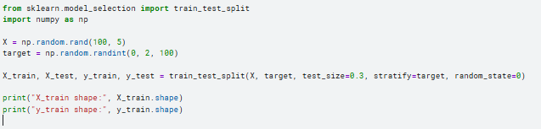
The Output:
Figure4.13 Splitting data into training and test set.

As shown in the Figure 4.13, This code prepares data for machine learning by dividing the data into a training set and a test set and also generates random data. It refers test_size=0.3 to The size of the test data and through it the size of the training data will be 0.7.

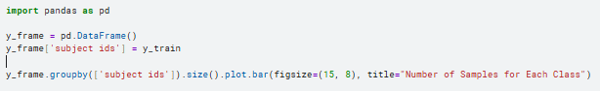
The Output:
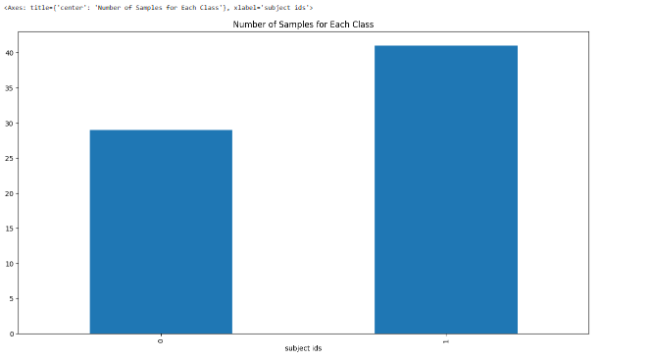
Figure4.14 Distribute and display data graphically.

As shown in the Figure 4.14 ,The code distributes the data and displays it in a chart to make it easier to understand.

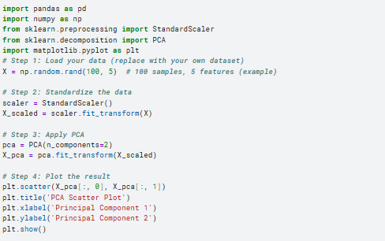
The Output:
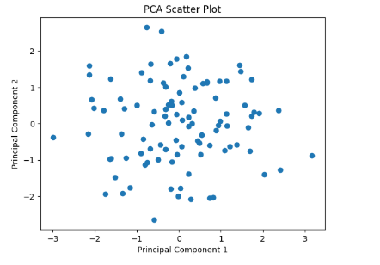
Figure4.15 Random distribution of data.

As shown in the figure, the code applies principal component analysis (PCA) to reduce the data dimensionality from 5 to 2, for easier visualization. The data is first normalized, then dimensionality is reduced using PCA, and the results are finally plotted in a scatter plot that illustrates the distribution of samples in the new space.

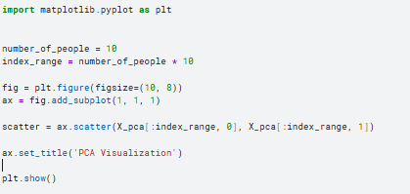
The Output:
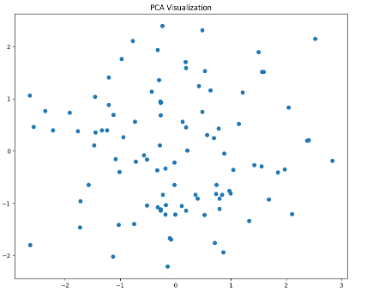
Figure4.16 Random distribution of data.

As shown in the Figure 4.15 and figure4.16 ,That code applies principal component analysis to a set of random data, reduces the dimensions between the data, and represents it graphically.

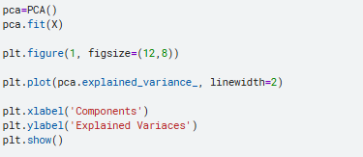
The Output:
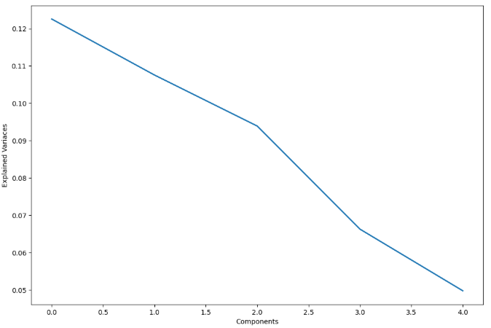
Figure 4.17 Explained variance curve.

As shown in the Figure 4.17, A curve that indicates all the data separately for interpretation and analysis by and shows the degree of variation or difference of each element from the other.

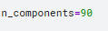
Figure 4.18 Retention data.

As shown in the Figure 4.18, The number of main components that are kept and here it means that the data dimensions will be reduced to 90 main components.

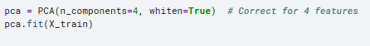
The Output:
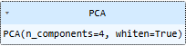
Figure 4.19 Reducing data dimensions.

As shown in the Figure 4.19, Reduce the degree of variance between data to increase the efficiency of machine learning on it and speed up the work of classification algorithms on it and the model CNN.

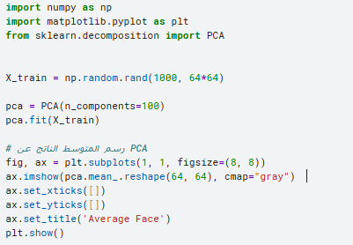
The Output:
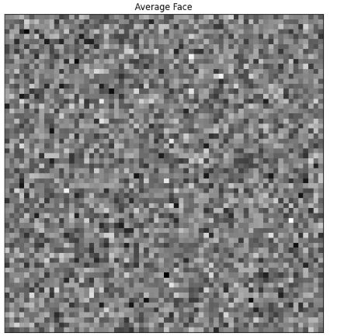
Figure 4.20 Average face.

As shown in the Figure 4.20, The code aims to find the general average of the images, which in turn helps in the data analysis process by understanding the basic patterns and common characteristics of the data, and it also works to process the images.

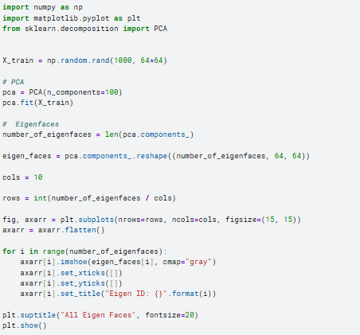

The Output:
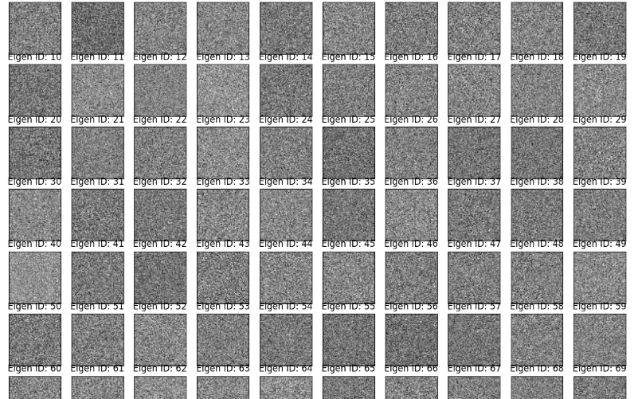
Figure 4.21 Principal Component Analysis.

As shown in the Figure 4.21, It helps in the process of recognizing facial features, which facilitates the process of classification and recognition of the face from the existing features.

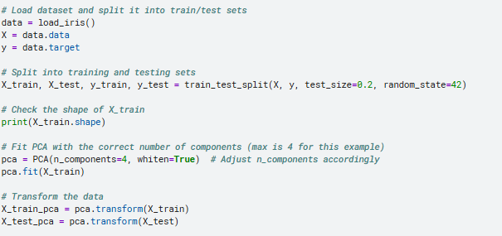
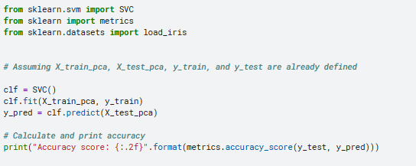
Figure 4.22 classification using SVM.

As shown in the Figure 4.22, This code demonstrates the accuracy of an algorithm's SVM work in classifying data for the dataset and the result for that(120,4). So The accuracy of SVC was 96%.

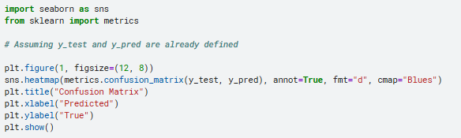
The Output:
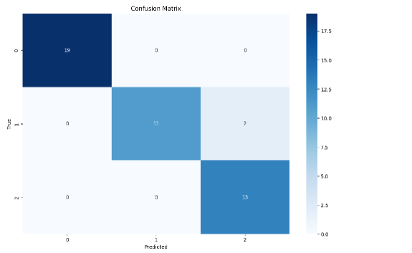
Figure 4.23 Confusion Matrix.

As shown in the Figure 4.23, This code shows the use of a type of matrix to display the performance of the machine learning model in classifying data. This matrix is ​​called a confusion matrix and aims to compare the actual values ​​with the values ​​predicted by machine learning.

The Output:
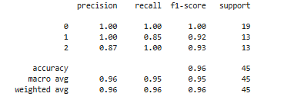
Figure 4.24 Classification Report.

As shown in the Figure 4.24, Create a report showing the accuracy of the model's performance in classification using CNN and SVM.
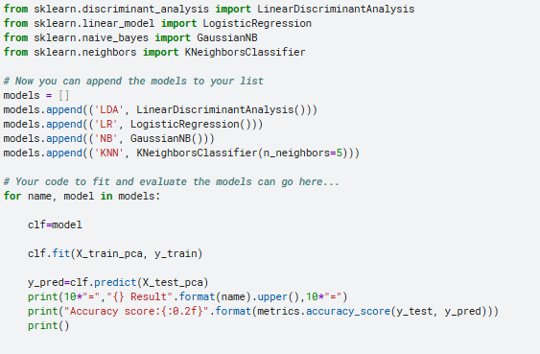
The Output:
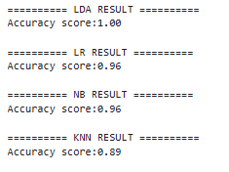
Figure 4.25 Accuracy Score.

As shown in the figure 4.25,Here it shows the accuracy when using multiple classification algorithms such as LDA, LR, etc. but the result shows that the LDA algorithm is the best in this project.

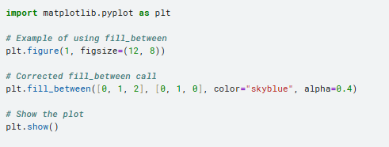
The Output:
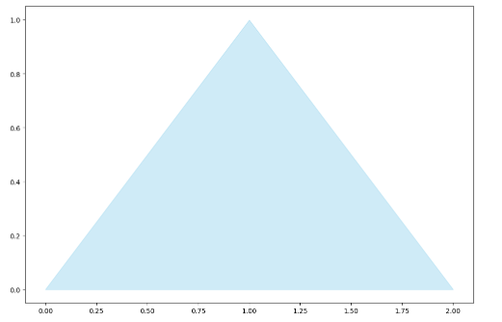
Figure 4.26 shaded graph function.

As shown in the figure 4.26, The shaded area represents the range of the data distribution.

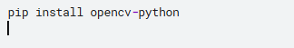
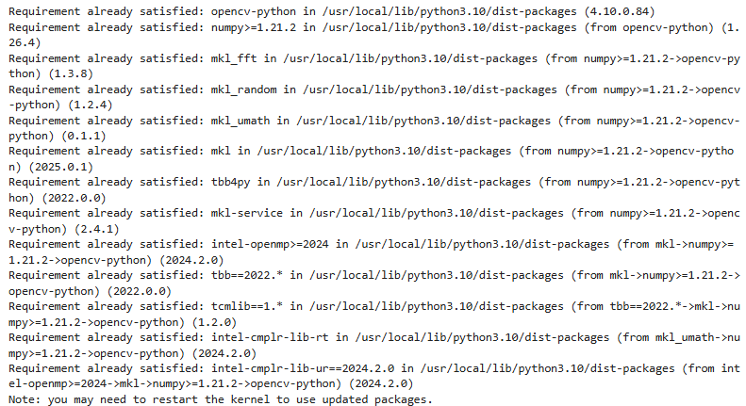
Figure 4.27 Open the library OpenCV.

As shown in the Figure 4.27, This library helps in recognizing faces from images.

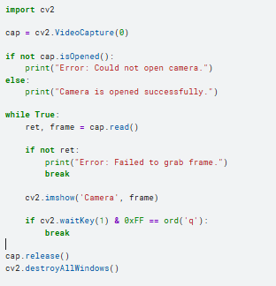

The Output:
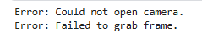
Figure 4.28 Open the camera.

As shown in the Figure 4.28, From the result shown in the code, we conclude that it is not possible to take pictures using the Kggle.

So we used the following code Figure 4.29.

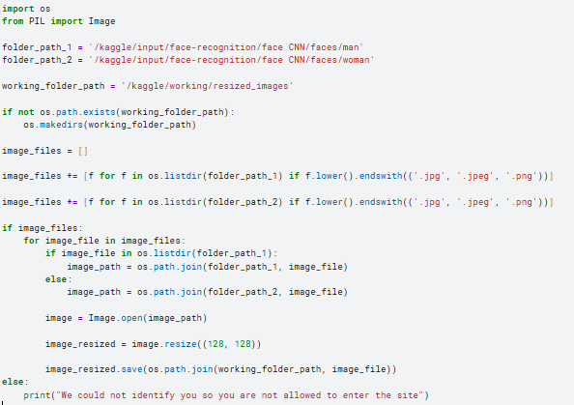
Figure 4.29 Specify the files used to verify data.

As shown in the Figure 4.29 This code shows the path of the files through which the data will be compared.

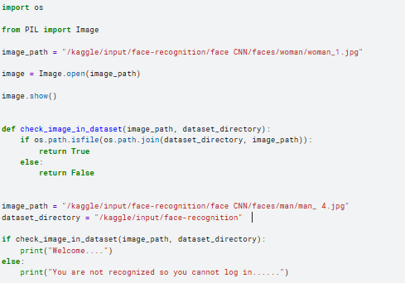
The Output:
Figure 4.30 Grant or deny access.

As shown in the figure 4.29, Make sure the user's photo is present or not in the data collection. If it is present, he will be allowed to enter and it will appear to him (Welcome….). If it is not present, he will be prevented from entering and the message will appear to him (You are not recognized so you cannot log in.....).

  - Summary
This chapter reviews the practical application of this system, explains and presents the final results for each part of the code, and outlines the requirements for running this code in the kaggle environment.

Chapter 5

CONCLUSION

  - Conclusion
The basic idea of ​​this research is to create a security system that solves the problem of using others' permissions to access websites. This system was created based on facial recognition technology "the secure access system using facial recognition". This research includes an explanation of the secure access system using facial recognition, in which many artificial intelligence techniques were used that facilitated the work of this system, as the importance of this system lies in identifying the people using the site and giving them their special permissions. This research led to the creation of a high-level security system that is fast and easy to use instead of using the traditional method of accessing websites.

  - Recommendations
Depending on the environment used to create the research, it is recommended not to use the Kaggle website because it is not possible to open the camera through it to observe the code results. It is recommended to use the Colab program to apply the code because it gives the authority to open the camera through it.

  - Future Work
    - Use multiple classes instead of the binary algorithm so that the system can identify the people authorized to enter and give them the permissions available to them on the site.
    - Using a high-resolution business model for face recognition instead of SVC.
    - Introducing the technology RNN into the system so that it can recognize faces in addition to showing a complete report on the person.
    - Create a system “Face Recognition Reporting” which will be based on technology.

REFERENCES
Wang, Mei, and Weihong Deng. "Deep face recognition: A survey." Neurocomputing 429 (2021): 215-244. | [1]
Mikołajczyk, Agnieszka, and Michał Grochowski. "Data augmentation for improving deep learning in image classification problem." 2018 international interdisciplinary PhD workshop (IIPhDW). IEEE, 2018. | [2]
Ayeni, J. "Convolutional neural network (CNN): the architecture and applications." Applied Journal of Physical Science 4.4 (2022): 42-50. | [3]
Chen, Leiyu, et al. "Review of image classification algorithms based on convolutional neural networks." Remote Sensing 13.22 (2021): 4712. | [4]
Arena, Paolo, et al. "Image processing for medical diagnosis using CNN." Nuclear Instruments and Methods in Physics Research Section A: Accelerators, Spectrometers, Detectors and Associated Equipment 497.1 (2003): 174-178. | [5]
Krizhevsky, Alex, Ilya Sutskever, and Geoffrey E. Hinton. "Imagenet classification with deep convolutional neural networks." Advances in neural information processing systems 25 (2012). | [6]
Shorten, Connor, Taghi M. Khoshgoftaar, and Borko Furht. "Text data augmentation for deep learning." Journal of big Data 8.1 (2021): 101. | [7]
West, Perry C. "Image Processing for Machine Vision–How Did We Get Here?." Quality 62.5 (2023): 27-27. | [8]
Guo, Guodong, Stan Z. Li, and Kapluk Chan. "Face recognition by support vector machines." Proceedings fourth IEEE international conference on automatic face and gesture recognition (cat. no. PR00580). IEEE, 2000.‏ | [9]
Hearst, Marti A., et al. "Support vector machines." IEEE Intelligent Systems and their applications 13.4 (1998): 18-28.‏ | [10]
Zhao, Shuping, et al. "Linear discriminant analysis." Nature Reviews Methods Primers 4.1 (2024): 70.‏ | [11]
LaValley, Michael P. "Logistic regression." Circulation 117.18 (2008): 2395-2399.‏ | [12]
Bayes, Thomas. "Naive bayes classifier." Article Sources and Contributors (1968): 1-9.‏ | [13]
Zhang, Harry. "The optimality of naive Bayes." Aa 1.2 (2004): 3. | [14]
Peterson, Leif E. "K-nearest neighbor." Scholarpedia 4.2 (2009): 1883.‏ Peterson, Leif E. "K-nearest neighbor." Scholarpedia 4.2 (2009): 1883.‏ | [15]
Abdi, Hervé, and Lynne J. Williams. "Principal component analysis." Wiley interdisciplinary reviews: computational statistics 2.4 (2010): 433-459. | [16]
Abdi, Herve, Lynne J. Williams, and Domininique Valentin. "Multiple factor analysis: principal component analysis for multitable and multiblock data sets." Wiley Interdisciplinary reviews: computational statistics 5.2 (2013): 149-179. | [17]
Wall, Michael E., Andreas Rechtsteiner, and Luis M. Rocha. "Singular value decomposition and principal component analysis." A practical approach to microarray data analysis. Boston, MA: Springer US, 2003. 91-109.‏ | [18]

